DATA ANALYTICS WITH R, EXCEL AND TABLAEU
ASSIGNMENT model evaluation assessment 15.1
ANSWERS

5. Problem Statement
1. Use the below given data set DataSet
a. Predict the no of comments in next H hrs
Ans
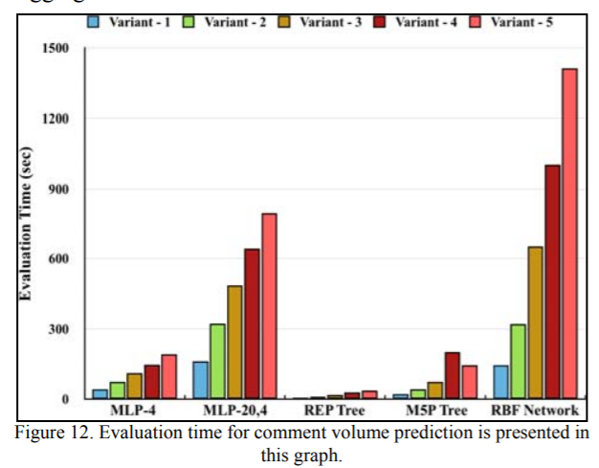
In case of REP tree the evaluation time is decreased from 10.844 Sec to 6.034 Sec for variant - 1 and from 46.871 Sec to 37.627 Sec for variant - 5. For M5P tree it again decreased from 34.440 Sec to 21.616 Sec for variant - 1 and from 518.638 Sec to 146.027 Sec for variant - 5. This shows that the evaluation time is directly proportional to the training dataset

b. Use regression technique
For analysis, we crawled the Facebook pages for raw data, pre-processed it, and made a temporal split of the data to prepare the training and testing set. Then, this training set is used to train the regressor and performance of regressor is then estimated using testing data (whose target value is hidden) using some evaluation metrics.

c. Report the training accuracy and test accuracy
Ans Training Accuracy
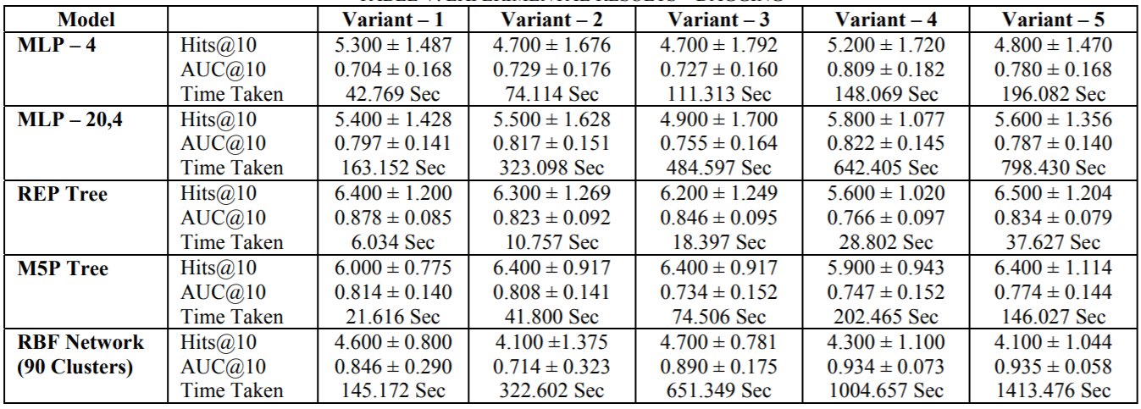

Testing Accuracy

